1/3" 6MP Low Lux CMOS with Fullhan 3K DSP, double layer 38*38+38*22(mm); support IR Led, warm LED, dual LED; H.265+H.264 video coding, support humanoid detection and frame remark, support dual streams, mainstream is 3200*1800, sub-stream is D1, support full net-com and ONVIF. With 0.5T Algorithms,more accurate. Support 2.4G&5G dual band WiFi, Bluetooth insert. |  |  | 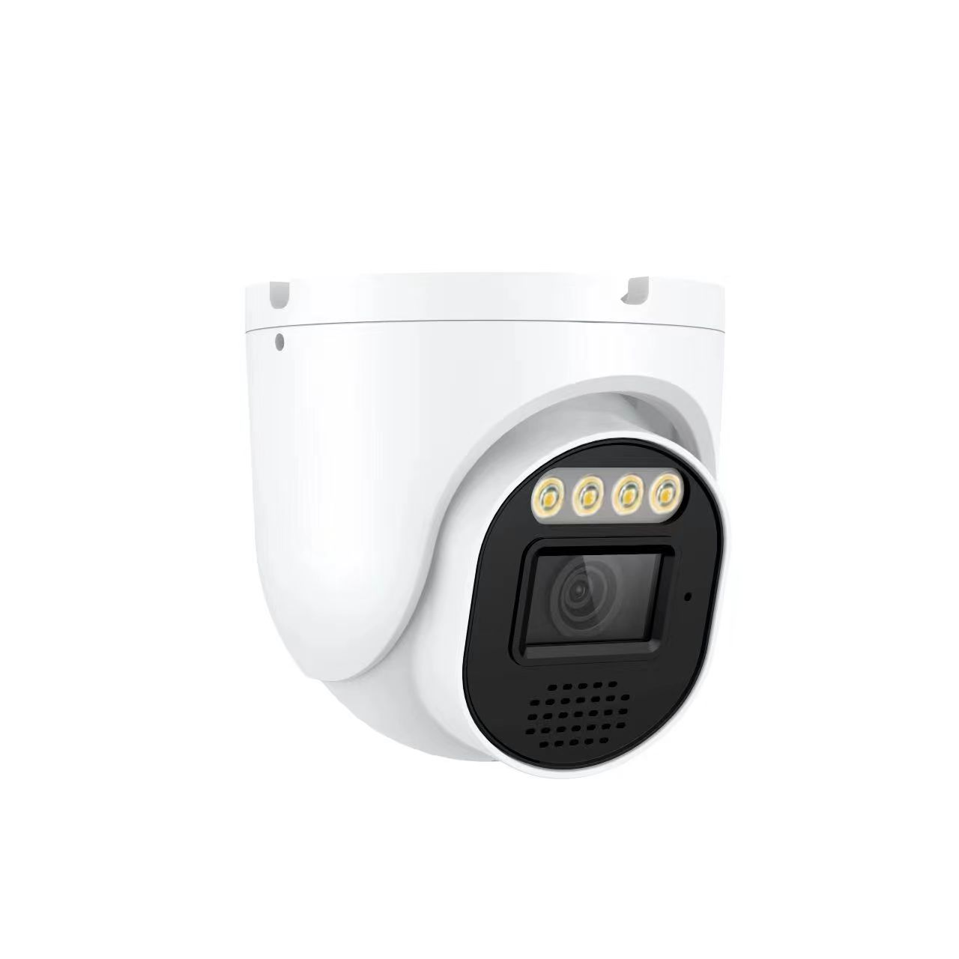
Model No. |  | FT-TYDF600S
Hardware
Chip |  | Fullhan 3K DSP + 1/3" 6MP CMOS
Lux |  | Color 0.05Lux@F1.2; black&white 0.005Lux@F1.2;
S/D |  | ≥50db(AGC OFF)
DWDR |  | DWDR: ＞80db
Interface
Audio Input |  | Audio MIC input
Audio Output |  | Built-in power amplifier circuit
LED Type |  | CDS, soft infrared, soft white light (support PWM) , onboard driver(optional)
Others |  | IRCUT, Reset
Options |  | Expandable IO
Video Coding
Coding Format |  | H.265, H.264
Resolution | Mainstream | 3200*1800, 1-20 fps/s
Resolution | Mainstream | 2880*1664, 2560*1440, 2304*1296, 1920*1080, 1280*720, 1-30 fps/s
Resolution | Sub-stream | 704*576, 640*480, 640*360, 352*288, 1-30 fps/s
Video Coding |  | 128Kbps-8192bps continuous adjustable
Subtitle Overlay |  | Support Channel Name, Date & Time, Code rate, Resolution & 4 lines characters adding
Data Transmission & Storage
Data Storage |  | Video, picture
Storage Method |  | Cycling Recording, Alarm Recording
Alarm Transform |  | Browser, management software, APP
Protocol |  | Standard ONVIF Protocol
Browser |  | Support IE6.0 and above browser(Internet Web Server)
Mobile |  | TUYA support IOS, Android
Basic
Working Temperature |  | -30℃ - +60℃
Working Humidity |  | 0% - 90%
Power Supply |  | DC12V / 150mA
Consumption |  | < 2W
Dimension |  | 38* 38*10mm + 38*22*5mm
Weight |  | 15g
T62N 6MP Double Layer Bullet Camera Module

